 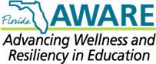

**Project AWARE**

**Advancing Wellness and Resiliency in Education**

Florida Project AWARE is a federal grant provided through the Substance Abuse and Mental Health Services Administration (SAMHSA). PCSB works in partnership with Florida Department of Education and the University of South Florida (USF). Pinellas County Schools received the Project AWARE grant in 2014 and is implementing the program in 10 district middle schools to assist in supporting schools, families, and students and to promote awareness of positive mental health.

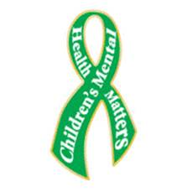

**Vision:**

Project AWARE will increase awareness and improve access to mental health supports to positively impact morale and climate within the school and community it serves.

**Mission:**

Project AWARE will provide training, coaching, and mentoring to our schools to help create a system and process for linking families with community mental health services and to promote an environment of positive mental health. We will accomplish this by addressing school mental health needs within a multi-tiered system of support and by using the gradual release model to ensure sustainability.

**Resources for counseling/support for children and families can be found by going online to:** [211tampabay.org/ChildrenMentalHealthResources](http://211tbc.bowmansystems.com/index.php/component/cpx/?task=search.query&view=&page=1&search_history_id=59336391&unit_list=0&akaSort=0&refinement=true&query=%20%20childrens%20%20mental%20%20health&simple_query=&all=childrens%20mental%20health). You may also dial 211 from any phone or download the 211 app and access resources near you via your smart phone!

Not what you’re looking for? Contact your school’s Florida Project AWARE System Navigator for additional support and assistance in navigating available resources!

**Jennifer Lotti:** [**lottij@pcsb.org**](mailto:lottij@pcsb.org)(Dunedin, Oak Grove and Fitzgerald Middle)

**Mary Knight-Martin:** [**knight-martinm@pcsb.org**](mailto:knight-martinm@pcsb.org)(Tyrone, Pinellas Park and Fitzgerald Middle)

**Anan Smith:** [**smithana@pcsb.org**](mailto:smithana@pcsb.org)(Bay Point, Largo and John Hopkins Middle)

**Rebecca Spencer:** [**spencerre@pcsb.org**](mailto:spencerre@pcsb.org)**(**Azalea, Meadowlawn and John Hopkins Middle)

**Vicki Koller:** [**kollerv@pcsb.org**](mailto:kollerv@pcsb.org)(Project AWARE Program Manager)